Scope of Work: App and Software development for Conveyor Group.
BUSINESS UNIT: COURIER AND INTERNATIONAL E-COMMERCE
- Order process Flow

- Workflow Process (Courier).

1. For Milex Corporate Customers:

SIGN IN PANEL
USER ID: CLIENT NAME (ABC CLOTHING)
PASSWORD: xxxx
2. Customer Options:
PREPARE HAWB
COMPANYNAME

Select from Dropdown Menu
CONTACT PERSON
Select from Dropdown Menu
CONSIGNEE NAME
Select from Dropdown Menu
CONTACT PERSON
Select from Dropdown Menu
CONSIGNEE ADDRESS
Select from Dropdown Menu
DESCRIPTION OF PRODUCTS
Select from Dropdown Menu

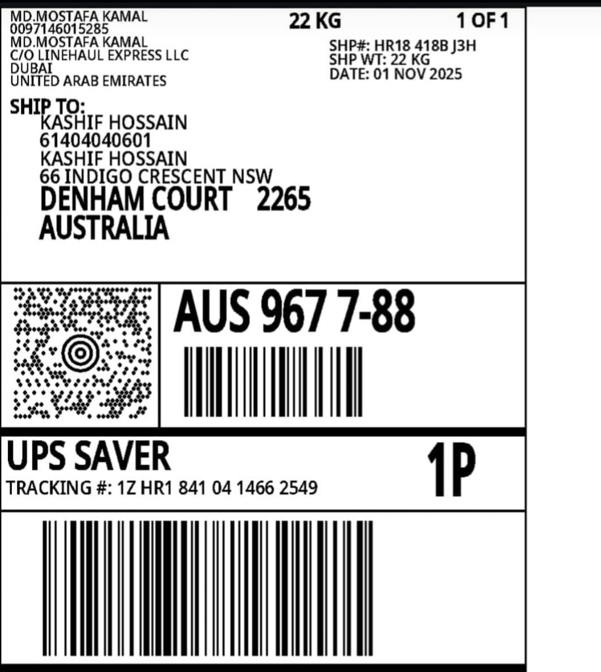

Field Reference:
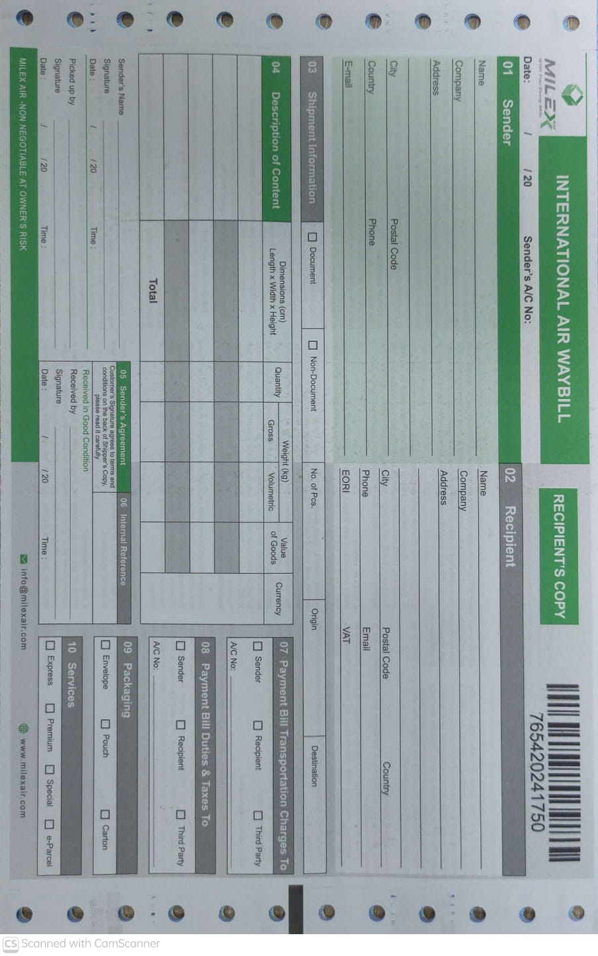
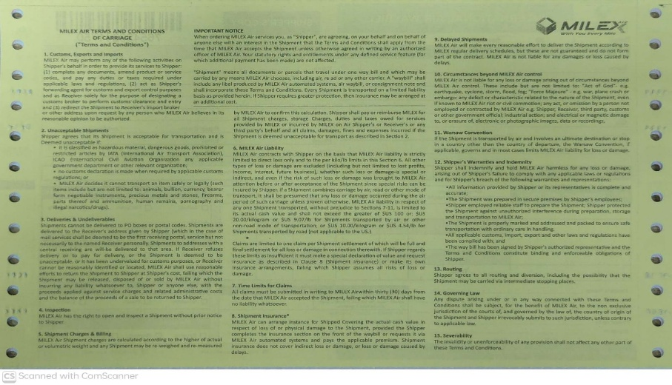
Customer must agree and tick these terms and condition to print final label.

3. When all HAWB information is filled out, System will generate Invoice:
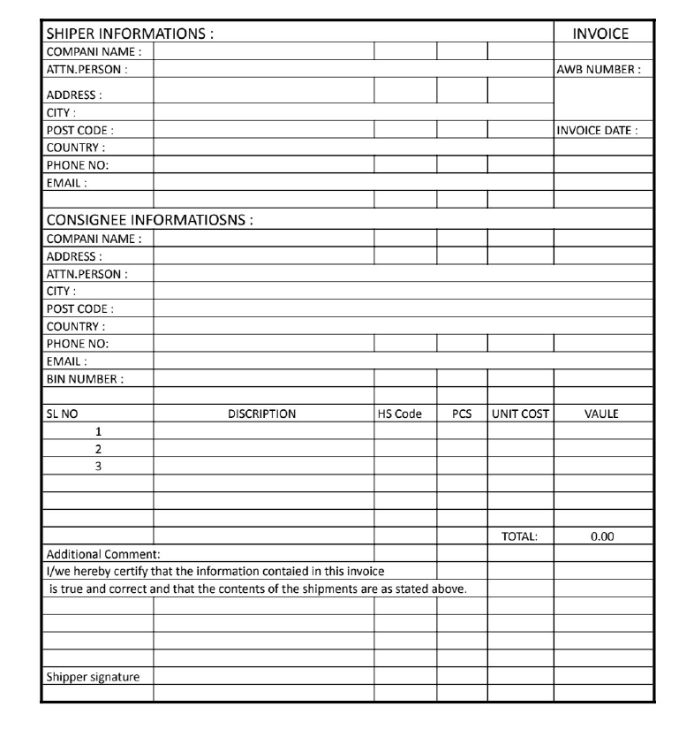
4. On PRINT, system will generate AWB Label and Final Invoice for pickup READY.

6. Customer will insert weight from their side but we will also have authority to correct weight if mismatched. WEIGHT CORRCTION by US. Correction of HAWB and INVOICE – MILEX OPERATIONS.
7. Generate Master AWB as mentioned in the end of International Ecommerce.

- Workflow Process (International E-Commerce).

- An order will be placed in the primary website by a customer through using the website and payment will be done using the Payment Portal.

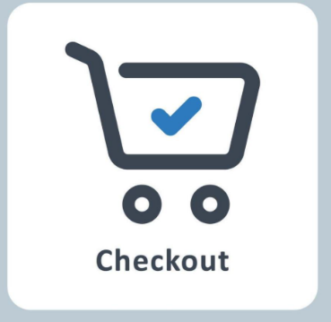
This order will generate ONE unique
Reference No. MBR000111222333
- AWB No. 11 digits.
- Barcode No. 12 digits.
We want this Number to be the same number – BARCODE, AWB, ORDER ID.
3. Additional information required: SHIPMENT WEIGHT

2. Label Printing: One Label will be printed for the Supplier/Vendor/Brand that will be stickered to each item according to their unique order number.

3. When ORDER is created, the Vendor will also have a Dashboard where he will be able to choose from a dropdown menu if shipment is ready or not. The cutoff time for Pickup is between 1800PM to 2000PM.
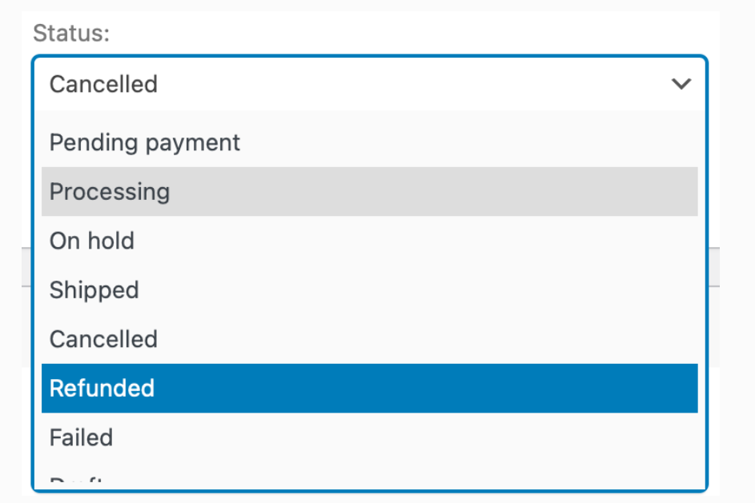
We want to add box for
REASON FOR NOT READY
READY DATE


UNIQUE FEATURE: EVERY ORDER MUST SHOW IN OUR DASHBOARD
CLICK
READY FOR PICKUP
NOT READY FOR PICKUP

4. Once shipment is ready, We want to choose the Courier from our end for arranging the pick up:
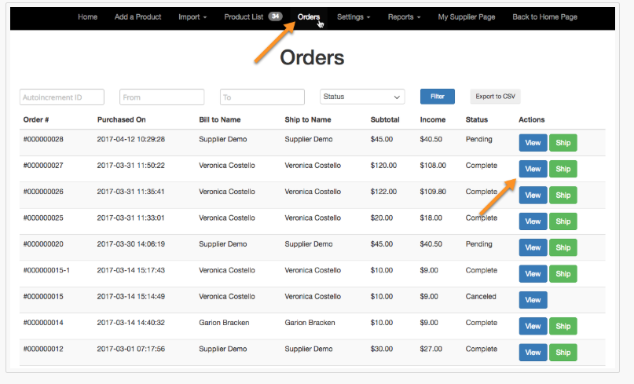 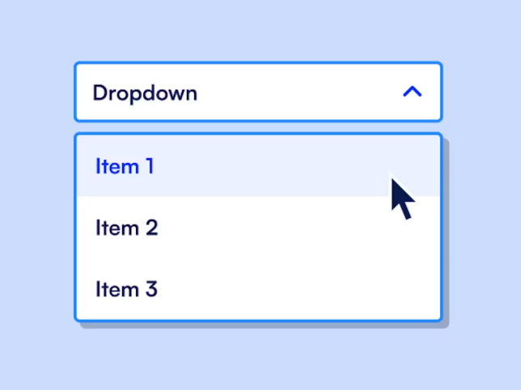
OTHER DOMESTICS
SUNDORBBAN
REDEX
PATHAO
SELF
CHOOSE COURIER

The selection from the drop-down menu will automatically create the order for the courier company for their next pickup location with the pickup time between 1800pm to 2000pm.

5. WE WANT TO INTEGRATE THE THIRD PARTY TRACKING TO OUR SYSTEM SO WE CAN TRACK AND TRACE THE EXACT LOCATION OF THE PARCEL/PARCELS AND ALSO ARRANGE FOR PICKUP FROM BANANI / JIGATOLA / MIRPUR / TEJGAON HUB IF NECESSARY.


6. Unique feature: We want to add Airlines or Load cutoff time function and integrate with pick up times to check if we can bring load to Hub for processing and fast transfer.

7. Printing THE FINAL MANIFEST from the software for preparing daily load for Airport transfer.

CONSOLIDATE MANIFEST: INPUT Manually checking and Input for each MANIFEST:

Input Fields 1:
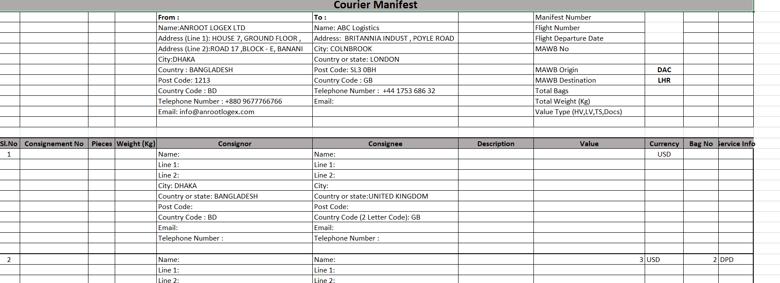
Input Fields 2:
MAWB NO. |  | xxxxxx |  | SHIPPER DETAILS | Select
AIRLINES NAME |  | xxxxxx |  | AIN NO. | Auto when selected
FLIGHT NO. | xxx | ETD | xxxx | CONSIGNEE DETAILS | Select
DATE | xxx | ETA | xxxx | AIN NO. | Auto when selected

GENERATE FINAL MANIFEST AND PRE-ALERT COPY.

8. THE OVERALL TRACKING FROM ORDER PLACED TO ORDER DELIVERY INTEGRATING ALL LOGISTICS SERVICE STAKEHOLDERS INCLUDING HUBS – AIRLINES – AIRPORT TO FINAL DELIVERY.

